JSPM’s
RAJARSHI SHAHU COLLEGE OF ENGINEERING
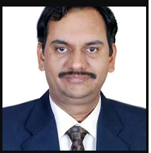
1. Name of the teaching Staff: - Dr. Ram B. Joshi
2. Designation: - Professor
3. Department: IT
4. Qualification: Ph.D (Computer Science & Engg.)
- ME (Computer Engg.) - First Class with Distinctions
5. Total Experience in Years: -30 yrs
- Teaching : - 25 yrs
- Industry : - 3 Yrs
- Research : - 2 Yrs
6. Paper Published
- National :- 04
- International :- 11
7. Paper Published in Conferences:-
- National :- 06
- International :- 10
8. PhD Guide ? Give Field & University
- Field :- Information Security
- University :- SJJT University ( Rajasthan)
9. PhDs /Project Guided
- PhD’s : 03 in Process
- Projects at Masters Level : 20
11. Professional Memberships:- LMISTE, LMCSI
12. Consultancy Activities:
- S/w Development with Pacific Microsystems Pune
Clients: NHPC, Hindalco, Reliance Industries Etc.
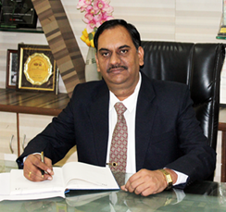
Publication :
https://scholar.google.com/citations?user=Q-AHdhUAAAAJ&hl=en

